**Electromagnetic**

**Practical file**

**Prince khatti**

**21HEL2131**

**B.Sc (H) Electronics**

**Semester 5th**

**Practical 1: Curl of Field**

**Code:**

clear, clf;

alpha=3;

omega=1;

[x,y]= meshgrid(-2 : .5 : 2,-2 : .5 : 2);%0.2 --> 0.5

M=length(x); N=length(y);

r2=x.^2+y.^2;

subplot(2,1,1)

for k=1:M

for l=1:N

Ax(k,l)=-exp(-r2(k,l)/alpha.^2)*y(k,l)*omega;

Ay(k,l)=exp(-r2(k,1)/alpha.^2)*x(k,l)*omega;

end

end

quiver(x,y, Ax, Ay)

axis equal

axis off

text(-4, 0, 'a)', 'fontsize', 14)

subplot(2,1,2)

hold on

axis square

C=curl(x,y, Ax, Ay);

contour (x,y,C,5)% 10> 5

axis equal

hold off

text(-4, 0, 'b)', 'fontsize', 14)

**Output:**

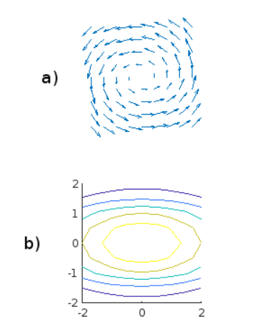

**Practical 2: Electric field due to line charge.**

**Code:**

clear;clf

[x,y]=meshgrid(-1: .1: 1, -1: .1: 1);

R1=(x.^2+(y-0.25).^2).^.5;

R2=(x.^2+(y+0.25).^2).^.5;

V=(1./R1)-(1./R2);

subplot (2, 1, 1)

R1=(x.^2+(y-0.25).^2).^.5;

R2=(x.^2+(y+0.25).^2).^.5;

V=(1./R1)-(1./R2);

surf(x,y,V)

axis off

view(- 37.5,20)

text(-3, -2, 35, 'a)', 'fontsize', 14)

subplot (2, 1, 2)

contour(x/5,y/5,V, 5)

hold on

axis square

[u,v]=gradient (V, .2);

quiver(x,y, -u, -v)

axis equal

axis off

hold off

text(-1/2, 1/4, 'b)', 'fontsize', 14)

**Output:**

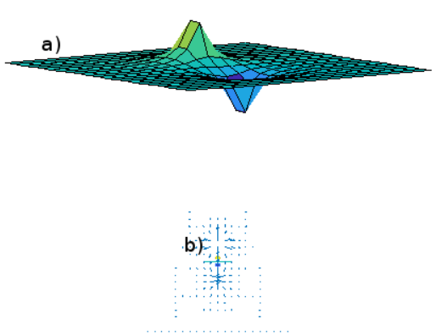

**Practical 3: Gradient of a scalar field**

**Code:**

clear;clf

[x,y] =meshgrid(-2: 2: 2, -2: .2: 2);

[xx,yy] =meshgrid(-2: .4: 2, -2: .4:2);

z=exp(-x.^2-y.^2);

zz=exp(-xx.^2-yy.^2);

subplot (2, 1, 1)

surf(x,y,z)

axis equal

axis off

view(-30,20)

text(-4.5, -2, 3, 'a)', 'fontsize', 14)

subplot (2, 1, 2)

contour(x,y,z, 5)

hold on

axis square

[u,v] = gradient (zz, .2);

quiver(xx,yy,u,v)

axis equal

axis off

hold off

text(-4, 0, 'b)', 'fontsize', 14)

**Output:**

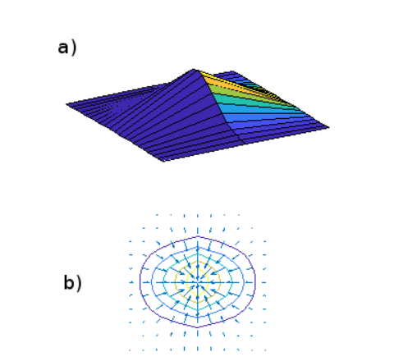

Practical 4:Divergence of Field

Code:

clear, clf;

alpha=3;

[x,y]=meshgrid(-2 : .5 : 2, -2 : .5 : 2);

M=length(x); N=length(y);

r2=x.^2+y.^2;

subplot(2,1,1)

for k=1:M

for l=1:N

Ax(k,l)=exp(-r2(k,l)/alpha.^2)*x(k,l);

Ay(k,l)=exp(-r2(k,l)/alpha.^2)*y(k,l);

end

end

quiver(x,y,Ax,Ay)

axis equal

axis off

text(-4,0,'(a)','FontSize',18)

subplot(2,1,2)

hold on

axis square

D=divergence(x,y,Ax,Ay);

contour(x,y,D,5)

axis equal

hold off

text(-4,0,'(b)','FontSize',18)

set(gca,'fontsize',18)

**Output:**

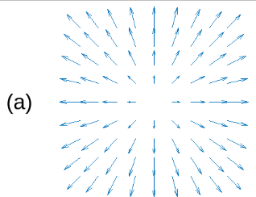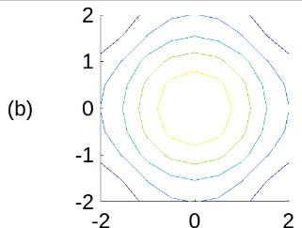

**Practical 5: Magnetic flux due to wire.**

**Code:**

clear; clf

warning off MATLAB:divideByZero

step=0.259;

%a=0.1;

a=1;

%L=1;

L=2;

[x,y]=meshgrid(-L: step: L, -L: step: L);

[Phi,R]=cart2pol(x,y);

NR=length(R);

NP=length(Phi);

for n=1:NR,

for m=1:NP,

Rn=R(m, n);

if Rn>a

B(m, n)=1./Rn;

else

B(m, n)=Rn./a^2;

end;

end;

end;

Bx=-B.*sin(Phi);

By=B.*cos(Phi);

angle=(0: 0.01: 1)'*2*pi;

u= a*cos(angle);

v= a*sin(angle);

fill(u,v, 'y')

hold on

fill(u/20,v/20, 'k')

quiver (x,y,Bx, By)

xlabel('x', 'fontsize',18)

ylabel('y', 'fontsize',18)

set (gca, 'fontsize',18)

axis equal

**Output:**

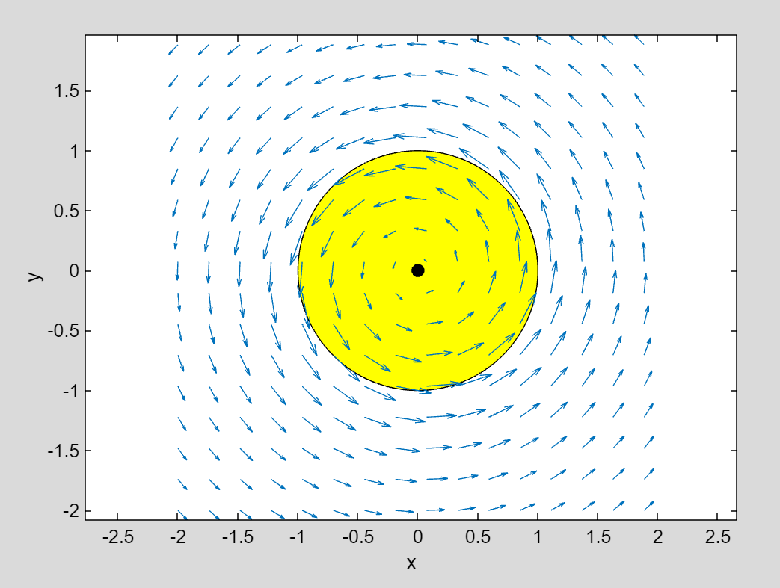

**Practical 6: Poisson’s equation**

**Code:**

clear;clf

clear;clf

[x,y] =meshgrid(- 5: 0.2: 5, -5: 0.2: 5);

voltage =(x.^2+y.^2)/4;

surf(x,y, voltage+ 5)

%mesh(x,y,V+10)

hold on

charge=del2(voltage);

mesh(x,y, charge)

view(-37.5,20)

xlabel('x', 'fontsize', 14)

ylabel('y', 'fontsize', 14)

zlabel('\rho_v & V(x, y)', 'fontsize', 14)

axis ([-5 5-5 5 0 20])

set (gca, 'fontsize', 14)

set (gca, 'zticklabel', [])

**Output:**

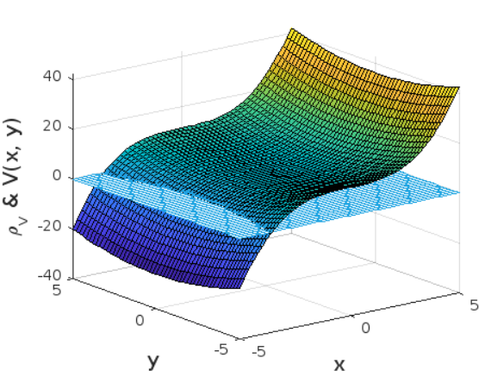

**Practical 7: Transformation of Coordinate systems.**

**Code:**

x= input("Enter the value of x: ");

y = input("Enter the value of y: ");

z = input("Enter the value of z: ");

Cartesian = [x, y, z];

%for cylindrical coordinate system

rho = sqrt((x^2)+(y^2));

phi = atan(y/z);

Cylindrical = [rho, phi, z];

%for shperical coordinate system

r = sqrt((z^2)+(rho^2));

theeta = atan(rho/z);

Spherical = [r, theeta, phi];

disp("The Cartisian vectors are :");

disp(Cartesian);

disp("The Cylindrical vectors are: ");

disp(Cylindrical);

disp("The Shperical Vectors are: ");

disp(Spherical);

**Output:**

